YOUR NAME HERE
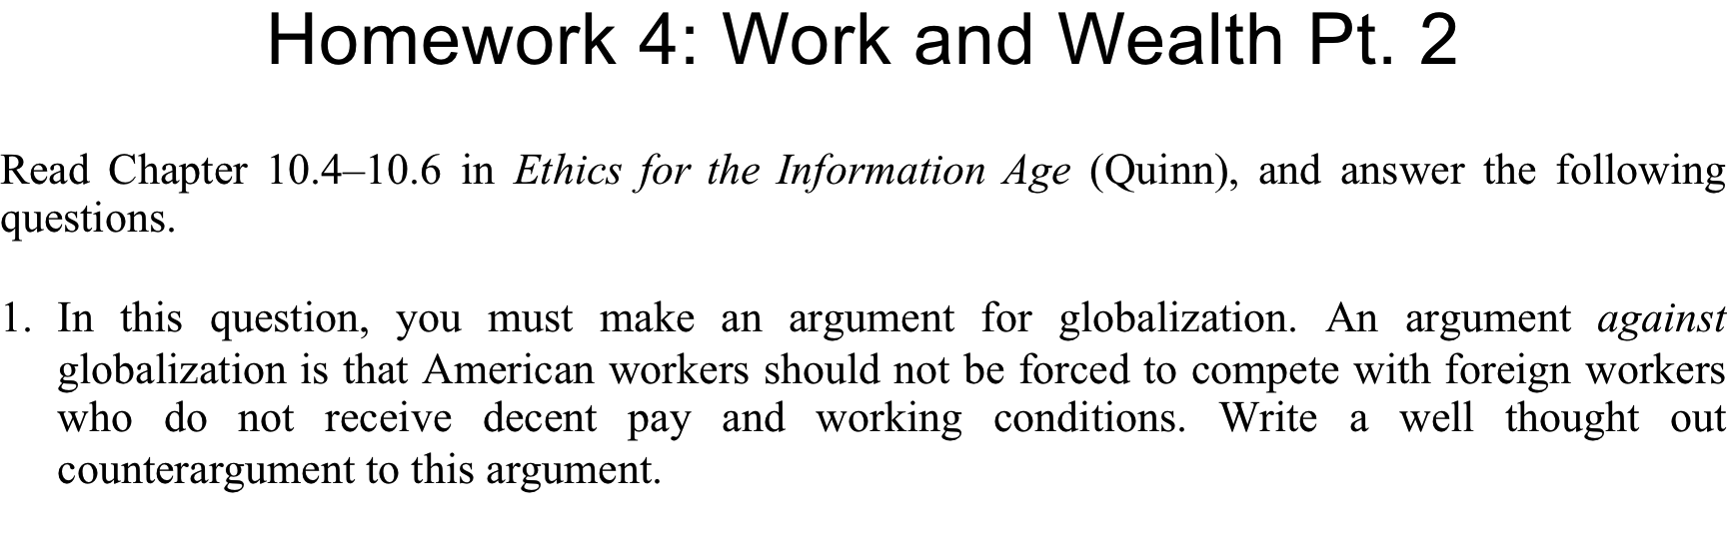
ANSWER HERE

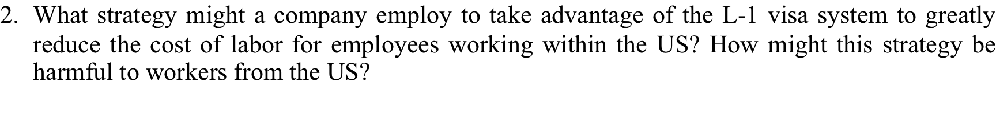
ANSWER HERE

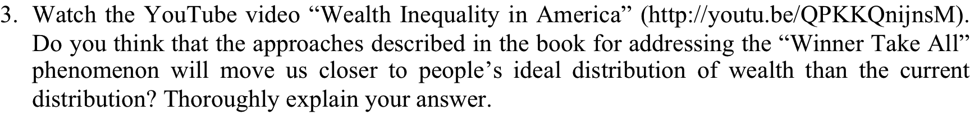
ANSWER HERE

ANSWER HERE

