YOUR NAME HERE
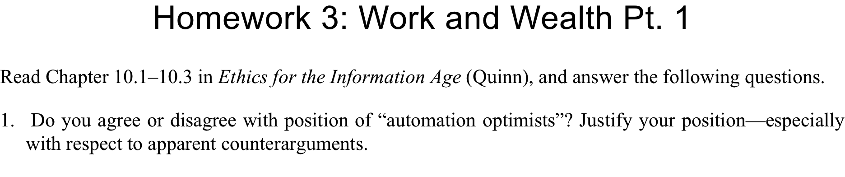ANSWER HERE
ANSWER HERE
ANSWER HERE
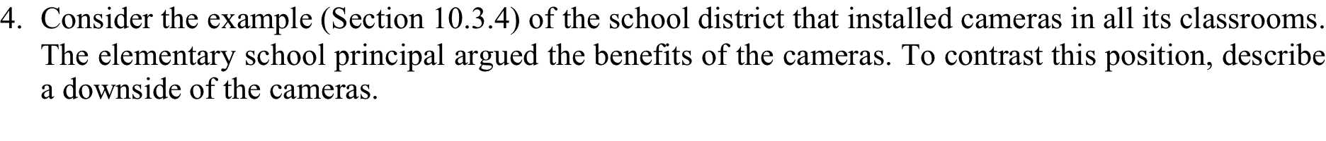ANSWER HERE

